People live here. It's a road in town with houses and shops. | 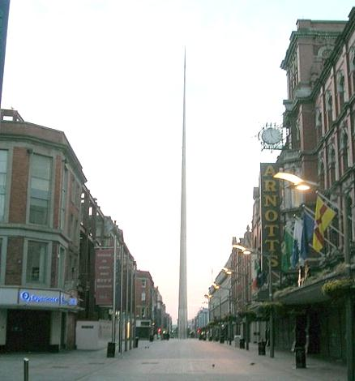  Word- Picture Definition
A wide road with trees on the sides. | 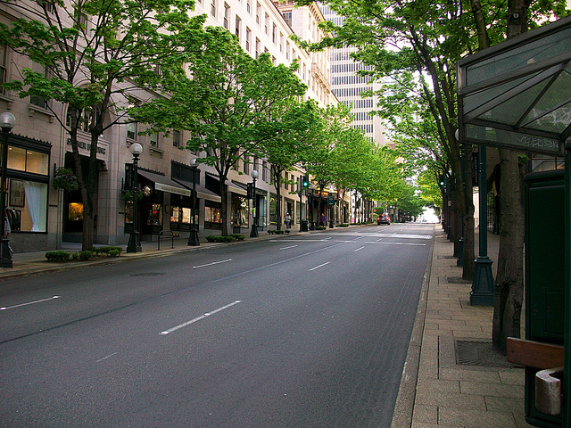
You can buy everything you need here: clothes, shoes….. There are also restaurants and cafes. | 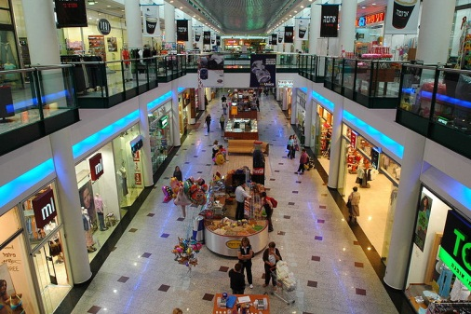
You can find books
here, sit quietly and read.

You can drink coffee and tea here and eat a sandwich or cake. | 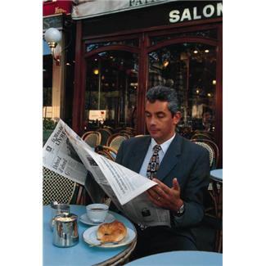
You learn here. | 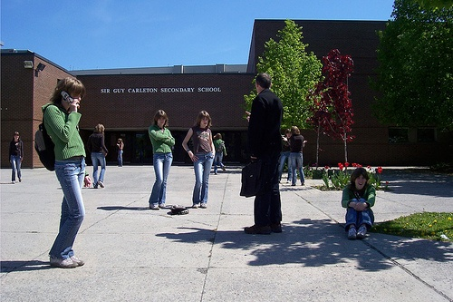
Here you can watch a play or a show. | 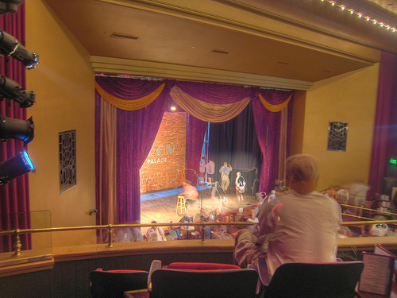

You come here when you need money. | 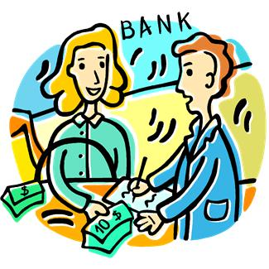
You can buy books here. | 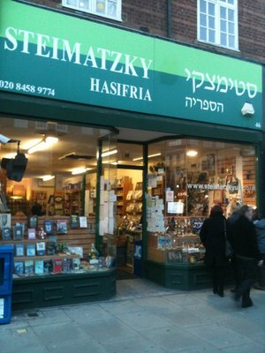
You can eat a meal here with your friends and family. | 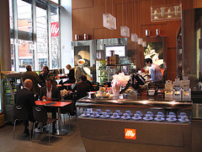

You sleep here when you travel. | 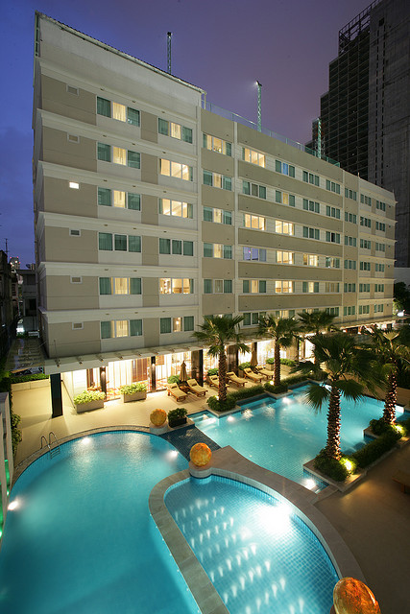
You can send letters from here and buy stamps. | 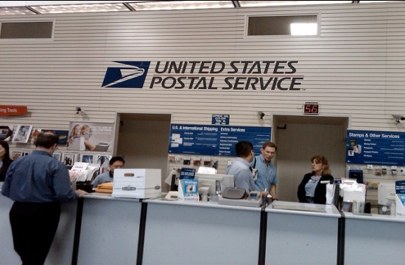
A big store with departments for different things (dishes, clothes, shoes, shampoo….) | 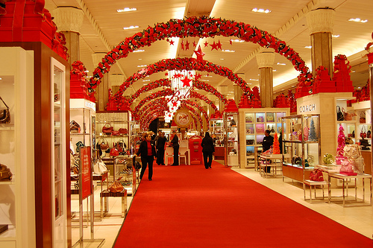

Here you buy food, vegetables, fruit, sugar, cheese and other things. | 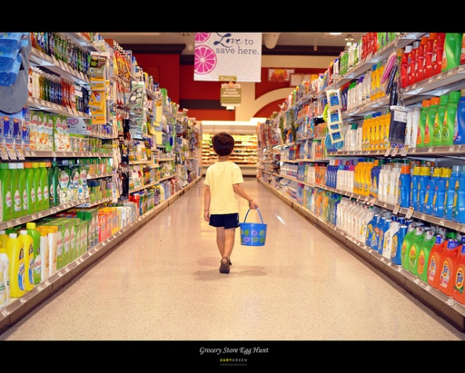
An underground (תת קרקעי) railway station in the city. | 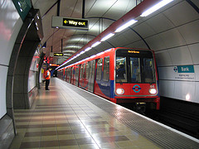
Police officers  work here. | 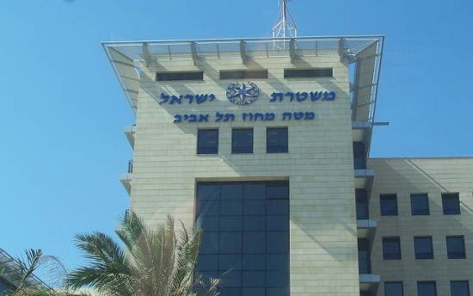

You can buy petrol for your car here. | 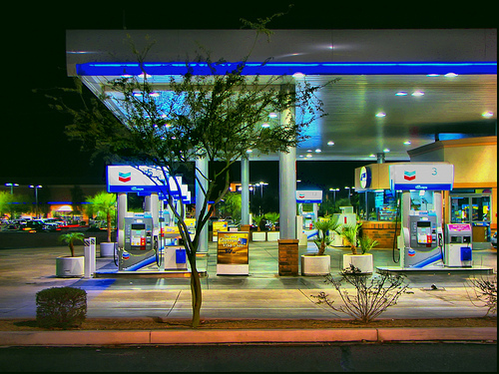
You can get on the bus here. | 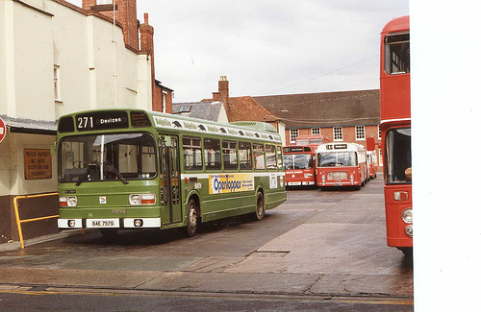
You can take  a train here and travel to  different places. | 